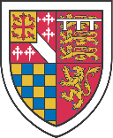

ST EDMUND’S COLLEGE

AFTERNOON TEA

Selection of Finger Sandwiches:
Scottish Smoked Salmon & Cream Cheese
Honey Roast Ham & Sweet Pickle
Classic Cucumber (V)

Served with
Hand Cooked Sea Salt Crisps

Selection of miniature Cakes:
Lemon Drizzle Sponge
Victoria Sandwich
Fruit Scones with Jam and Cream

Selection of Birchalls Teas & Filter Coffee

£16.50 per head + VAT

Add a glass of Prosecco for £5.00 pp

